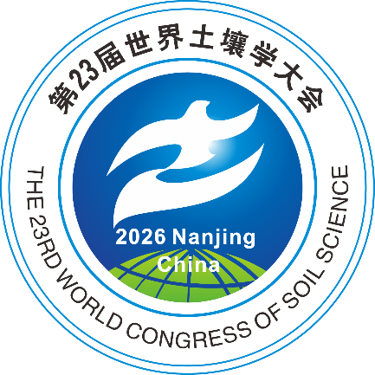
Attendance Grant for Council Member Representatives from Low- and Middle-Income Countries of World Congress of Soil Science 2026

1. Introduction
The International Union of Soil Sciences (IUSS) and the Soil Science Society of China (SSSC) are pleased to announce the Attendance Grant for the World Congress of Soil Science 2026 (WCSS2026). This initiative is designed to support the representatives of IUSS Council members from low- and middle (lower-middle and upper-middle) income countries (as classified by the World Development Indicators), enabling their participation in the Congress, which will take place from 7–12 June 2026 in Nanjing, China.

This funding aims to encourage and assist representatives of IUSS Full Member from less developed countries who are constrained by limited budgets to attend the Congress. A limited number of funding (approximately 20) will be granted. Each selected applicant will receive up to USD $3,000 to cover eligible expenses such as registration fees, flight tickets, and accommodation.

2. Eligibility and Requirements
Applicants must be nominated by an IUSS Full Member (a National Soil Science Society or a National Academy). Each society can nominate only one candidate. Applications must be submitted in English to wcss2026@issas.ac.cn by 24:00 (UTC+8) on 7 February 2026, and must include the following documents:
- An endorsement letter signed by your national soil science society.
- An application letter (in PDF) specifying the requested funding amount (maximum $3,000 USD).
- A Curriculum Vitae (in PDF, maximum two pages) including nationality, educational background, and professional experience.
- A candidate is encouraged to submit an abstract for an oral presentation or poster to the congress. If the abstract is submitted, please attach the email message confirming your submission.

3. Selection and Announcement
A Selection Committee comprising appointed members from the IUSS Executive Committee and SSSC will evaluate all applications. Successful applicants will be notified via email by 28 February 2026 (UTC+8). The results will also be published on the official WCSS2026 website (https://www.23wcss.org.cn/) and the IUSS website (https://www.iuss.org). The decision of the Selection Committee is final and not subject to appeal.

For any inquiries, please contact wcss2026@issas.ac.cn or call +86-025-86881992.

We look forward to your valuable contributions to WCSS2026!

